S&M-CM/170/Tariff/11-12/65 dt @ Chennai 29.09.2011.

Sub : 100 SMS/Day/SIM restrictions in 2G/3G Prepaid/Postpaid Mobile services in TN LSA - reg.
Ref : C.O. Lr.No: 2-15/2010/PP-CM(Pt I) dt 28.9.2011.

Approval of the Competent Authority is hereby conveyed for implementation of TRAI regulations viz., restriction of 100 SMS/Day/SIM , as per the letter cited above, in Tamilnadu LSA (incl. CHTD) with effect from 00:00 Hrs of 29.09.2011.

The details are given below:-

- All TamilNadu & Chennai TD Mobile customers in 2G/3G
- prepaid/postpaid services have been restricted to make only 100 SMS per day per SIM as per the TRAI regulatory order.
- CTOPUP numbers have been exempted from this restriction.
- Customers who have already activated STV 53 ( i.e. upto 26.9.2011), will get their validity suitably extended, so as to allow them to use the balance SMS in their account.

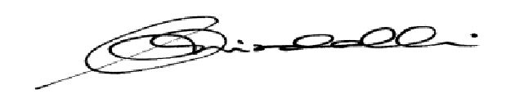
This is for the information of all concerned please.

(K.R. Aravindavalli)

AGM(Marketing-CM)

To

GM (NW-O CM), Trichy -1/ Coimbatore – For information & necessary action please.
GM(S&M-CM), Chennai Telephones, Chennai for information pl.
GM (F) / Sr. GM (TR) TN Circle, Chennai for information please.
DGM/DE In charge IN - Trichy & Bangalore - for necessary action please.
DGM(NW-O)/DE Commercial, Coimbatore - For information & necessary action please.
Heads of SSAs, -- for kind information and necessary action please.
DGM (Sales) & AGM (Sales), Chennai-6 –For information and informing Sales Heads , franchisee managers and retail managers and other Channel partners along with commission structure as applicable.
DGM (CS), Chennai-6 - For information and informing Call Centre/Customer Service Centre Officials and ensure uploading the information on the website “tamilnadu.bsnl.co.in” .
DGM(S&M-CM)/AGM(S&M-CM), Chennai Telephones, Chennai – For information please.

